Demo Watercolour materials used by David McEown

Palette
- white watercolour palette, should have at least 3 mixing pans, lots of cake wells. For travel I have one that folds and a thumb hole to hold it. Pictured below is my studio palette.
Colours left to right; Winsor Blue (green shade), Turquois blue (Holbein), Horizon Blue (Holbein), Cadmium Yellow Lemon, Aureolin, Winsor Orange (red shade), Scarlett Lake, Permanent Rose, Quinarchridone Violet (Stevensons), Winsor Violet, Ultramarine Blue. (most brands are Winsor Newton or Holbein)

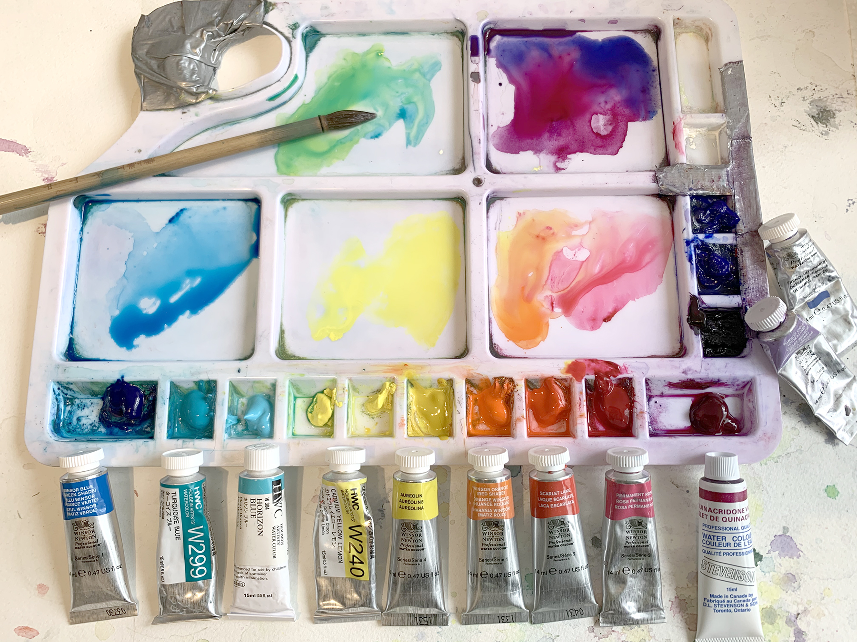

Watercolour Paper
A’rches 140lb cold press (bright white version

painting support board, 16” x 23”, for 1/2 sheet or 16 x 12 for 1/4 sheets to clip my paper on to. For Travel and keeping light, I have a folder made out of plastic corrigate (common display board) that way paintings are stored inside and you can attach and paint on top. This board has a custom attachment for a photographic tripod/ easel.

Watercolour Brushes
Chinese bamboo “wolf” hair brushes. (about size 10-12 ) , also a 1 inch kolinski sable flat brush.

Other Equipment
Bulldog Clips, HB Pencil, kneaded eraser, knife , water container or collapsible plastic container very well for traveling, paper towel.

